First image:

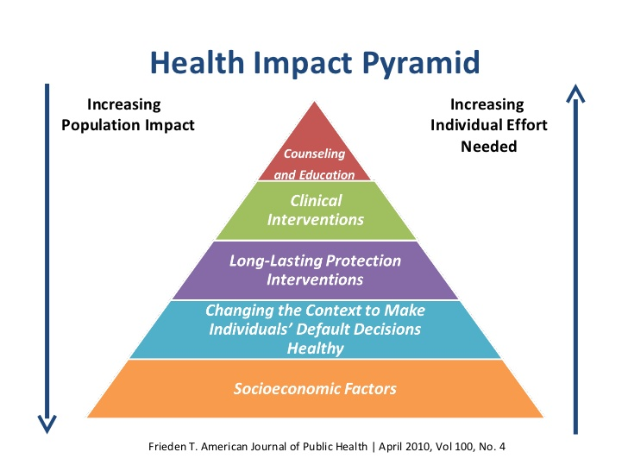

Image description for first image:

Title: Health Impact Pyramid

A triangle with five rows, with the words:

Top/tip of the triangle: Counseling and Education

Second row: Clinical Interventions

Third row: Long-lasting Protection Intervention

Fourth row: Changing the Context to Make Individuals’ Default Decisions Healthy

Fifth/base of the triangle: Socioeconomic Factors

Next to the pyramid, there is downward arrow starting from the top to the base with the words: “Increasing Population Impact.” There is also an upward arrow starting from the base to the top with the words: “Increasing Individual Effort Needed.”

The source of this picture is from Frieden T. American Journal of Public Health | April 2010, Vol 100, No. 4

Second image:

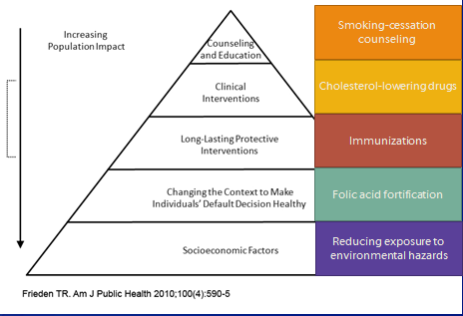

Image description for the second image:

A triangle shape with five rows, with the words:

Top/tip of the triangle: Counseling and Education, and the example: smoking-cessation counseling

Second row: Clinical Interventions, and the example: cholesterol-lowering drugs

Third row: Long-lasting Protection Intervention, and the example: immunizations

Fourth row: Changing the Context to Make Individuals’ Default Decisions Healthy, and the example: folic acid fortification

Fifth/base of the triangle: Socioeconomic Factors, and the example: reducing exposure to environmental hazards

Next to the pyramid, there is a downward arrow starting from top to bottom with the words: “Increasing Population Impact.”

The source of this picture is from Frieden TR. Am J Public Health 2010; 100(4): 590-5